Strathmore Campus Safaricom Hackathon 2019

SERVICE INTEGRATION AND API DOCUMENTATION

Table of Contents
1.0 Introduction……………………………………………………………… 2
2.0 High Level Hierarchy…………………………………………………… 2
2.1 Hierarchy Diagram……………………………………………… 2
2.2 Hierarchy Description…………………………………………... 2
3.0 Components Classification……………………………………………… 3
3.1 Presentation Layer………………………………………………. 3
3.2 Controller Layer…………………………………………………. 4
3.3 Business Layer…………………………………………………... 4
3.4 Record Layer……………………………………………………. 5
3.5 Data Access Layer………………………………………………. 6
3.6 Database Layer…………………………………………………… 7
4.0 Process View……………………………………………………………... 8
4.1 Description………………………………………………………. 8
4.2 Application Thread………………………………………………. 8
4.3 Presentation Thread……………………………………………… 8
4.4 Connection Thread………………………………………………. 9

- Introduction
NB: on my own assumption since all the task required to be tackled were doable from a client – server form of architecture, I created a php client adapter (shared) that will prepare data for a common web service that I created to handle several of the tasks required specifically (Q1, Q2, Q3 (i)). I called my ws MyConnet as a uniform term.

My SERVICE INTEGRATION AND API HACKATHON (MyConnect)Architecture Document is designed to illustrate and identify the high level architecture systems used to design and implement the “ MyConnect” application. The document contains an overall view of the system hierarchy, logical views of the system components, and a process view of the system’s communication.

2.0 High Level Hierarchy

2.1 Hierarchy Diagram
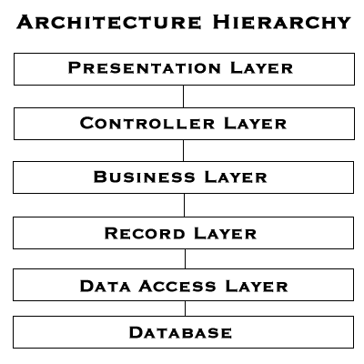
PHP CLIENT API
(Preparing data requested)

2.2 Hierarchy Description

The architecture system for the “ MyConnect” application is an n-tier architecture. This architecture system is designed to allow for proper information hiding, modular components, and single system dependencies. The abstraction of the presentation layer, and consequently the User Interface (UI) which in this case is PHP adapter to channel/prepare data for “MyConnect” application to allow for a flexible pipeline for the optimization of the UI to meet customer needs and expectations. This creates a SOAP web service (in the form of XML in the SoapUI or Postman test tools), that receives serial client device data.

3.0 Components Classification

3.1 Presentation Layer

Purpose: To prepare data that the web service can harness and receive “MyConnect” responses therefore create a fluid and efficient user experience.

Specific Nature: The presentation layer (php adapter) will be in charge of preparing the request parameters including creation of the authentication key to validate request with “MyConnect” application. This layer will also be in charge of the spawning of appropriate threads from the client-end requests.

3.2 Controller Layer

Purpose: Processes and responds to events, typically from the client API and responds with a success or fail response.

Specific Nature: The controller layer in our program will be in charge of getting the prepared request from the client’s API or SoapUI/Post SOAP requests, it will channel specific request to their respective business logic implementations. This will consequently notify the presentation layer with an updated for corresponding request.

3.3 Business Layer

Purpose: This layer is in charge of the heavy algorithm business logic. It has access to the utilities that perform complex solutions in form of decoupled functions. It’s basically the gateway to the record access layers and record layer

Specific Nature: This layer will be used to compute the algorithm for finding the user’s appropriate response. This class is in charge of getting the appropriate error or success message based on the actions of the user or implementation of the algorithms.

3.4 Record Layer
Purpose: This layer prepares the records pulled from the database so that the business layer can get the appropriate response.

Specific Nature: It handles creation of data objects that conform to the general request formats i.e. converting the Array Lists to JSONArrays etc.
3.5 Data Access Layer

Purpose: This layer is in charge of communicating to the database. This layer should handle all of the database transactions and connectivity ensuring a harmonized non-blocking database manipulations.

Specific Nature: This layer will be in charge of communication to our database which will in turn lead to populating the record layer. Our database is sql server 2012. The config file containing connection urls is accessed by a class utility in charge of reading a file and populating all of the data source urls, queue urls according to all of the different types of connections the system does.

3.6 Database Layer

Purpose: This layer is in charge of storing data in persistent storage.

Specific Nature: These will be our database management system. Helps view the actions committed to our database.

4.0 Process View

4.1 Process View Description

The Process View is essential in understanding how the separate components and subcomponents communicate with each other in a concurrent application. By better understanding the necessary paths of communication between the components, it may be possible to optimize the data flow and storage of the application, as well as ensuring thread-safety.

4.2 Application Thread

This thread is the main application thread that is created at runtime of the program. The program creates the thread; this is not a user created thread. This thread handles the basic program flow by handling of user input to the expected response.

4.3 Presentation Thread

This thread is user created, when the application generates a request the client API will ultimately echo the now prepared request thread to “MyConnect”.

4.4 Connection Thread
Invoked by our Application thread above and start connecting to the relevant resource.

TESTING THE APPLICATION

The application connects to a db on my local machine but for the ws to consume calculators can be run via any ide and produce good results of the webservice.

